King Fahd University of Petroleum and Minerals
Information and Computer Science Department

ICS 103: Computer Programming in C
Spring Semester 2009-2010 (Term-092)

Major Exam-I

Time:100 minutes Thursday, March 25, 2010

Name:
ID#:

PLEASE CIRCLE YOUR SECTION BELOW:

Section | 01 | 02 | 03 | 04 | 05 | 06 | 07 | 08 | 09
Instructor | Balah | Darwish | Balah | Darwish | Darwish | Bouche-khma | Balah | Bouche-khma | El-Maleh
Time | UT-7-8 | SM-7-8 | UT 9-10 | SM 9-10 | UT 1:10-2 | SM 1:10-2 | UT 8-9 | SM 8-9 | UT 9-10

Question # | Maximum Marks | Obtained Marks
1 | 10x2 =20
2 | 8
3 | 15
4 | 6
5 | 9
6 | 10
7 | 14
8 | 18
Total | 100

Notes. 1. Make sure you have Seven pages including the cover page.
2. Closed book and notes
3. Write clearly, briefly and precisely
4. Cheating will result in ZERO grade

Good Luck

Question 1: (20 points- 2 points each expression)

Find the values of the following expressions.
expression | Value
!1 && 1 | 0
(double) (11/4) | 2.0
11*2>15+4 | 1
335%100%3 | 2
4 > 2 > 1 | 0
!( 100/25 == 20/4) | 1
1 != 7 > 0 | 0
(int) 6.6/1.2 | 5.0
33.1+9/2*4.0 | 49.1
7 && 10 > 8 | 1

Question 2 (8 points)
Consider the following program. What will be the output for the different values of x typed by the user.

#include <stdio.h>
int main() {
int x ;
Value of x typed  By user | Program output
4 | 7
2 | 8
5 | 10
15 | 19
scanf("%d",&x);
switch(x) {
case 4:
case 2: if(x==4)
x=x-3;
x=x+1;
case 5:
case 0: x=x+2;
case 3:
case 1: x=x+3;
break;
default : x=x+4;
}
printf("%d\n",x);
return 0;}

Question 3 ( 9+6=15 points)
Determine the output of the following programs for each of the input values entered by the user. If no output displayed, write “no output”
I)
#include <stdio.h>
int main(void)
{
User Input | Program Output
12F 13 14 | No output
8T 25T 10T | Two
5T 30T 40T | Three
int a, b, c;
scanf ("%d%d%d",&a ,&b,&c);
if (a<10)
if (b<20)
printf("One\n");
else if (c>a && c<b)
printf("Two\n");
else
printf ("Three\n");
return 0;
}

II)

#include <stdio.h>
int main(void)
{
User Input | Program Output
6 4 4 | First and third are equal
0 0 0 | First and second are equal
2 2 1 | The three numbers are equal
int a, b, c;
scanf ("%d %d %d",&a , &b, &c);
if (a==b==c)
printf("The three numbers are equal \n");
else if (a==b)
printf ("First and second are equal \n");
else if (a = c)
printf ("First and third are equal \n");
return 0;
}

Question 4 (6 points)
Show the output of the following program in the space provided below it. Each square corresponds to one space.
#include <stdio.h>
#include <math.h>
int main(void) {
double i=-99.999;
printf("%5.0f%8.2f\n",i,i);
printf("%5d%7.1f\n",(int)i,fabs(i));
return 0;
}

 | - | 1 | 0 | 0 |  | - | 1 | 0 | 0 | . | 0 | 0
 |  | - | 9 | 9 |  |  | 1 | 0 | 0 | . | 0

Question 5 (9 points )
Write the corresponding mathematical or C expression.
All variables are of type double.
C EXPRESSION | Mathematical Expression
(x*x-3*x)/sqrt(pow(x,2-y)+1)-2*x | $$\frac{x^{2}−\text{3x}}{\sqrt{x^{2−y}+1}}−\text{2x}$$
sqrt(fabs(5-x)+y)/x+y | $$\frac{\sqrt{\left|5−x\right|+y}}{x}+y$$
(2*x+5/x)*(4*x-y/(pow(x,y)+2)) | $$\left(\text{2x}+\frac{5}{x}\right) \left(\text{4x}−\frac{y}{x^{y}+2}\right)$$

Question 6 (10 points )

Consider the following flowchart. It is implemented using simple if statements (if without else or else if). Put the right condition for each of the if statements so that the corresponding message is printed.
Note: Write the minimum number of conditions for each case; for example a>60 and a> 100 has to be written as a>100 only.
a>=70
a < 30
false
true
“outside”
a<50
“low”
“medium”
false
a<90
“very high”
“high”
true
false
true
true
false

if( a>=50 && a<70 )
printf("medium");
if( a>=70 && a<90 )
printf("high");
if( a>=30 && a<50 )
printf("low");
if( a>= 90 )
printf("very high");
if( a<30 )
printf("outside");

Question 7 (14 points )
Write a C program that will find and display the radius of a sphere given its area or volume.
The program will display 2 choices for the user for input. Once the user selects the choice, the program will ask for the input and finds and displays the sphere radius.
Define PI as a constant and use a value of 3.1416 for it.
$\text{volume}=\frac{4}{3}π r^{3}$ $\text{Area}=4π r^{2}$
Below are sample executions of the program.
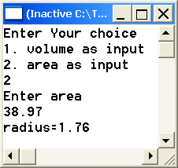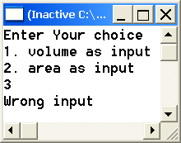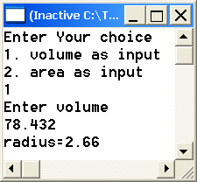

#include <stdio.h>
#include <math.h>
#define PI 3.1416
int main(void) {
double radius, input;
int choice;
printf("Enter Your choice\n");
printf("1. volume as input\n");
printf("2. area as input\n");
scanf("%d",&choice);
switch (choice) {
case 1: printf("Enter volume\n");
scanf("%lf",&input);
radius=pow(3*input/(4*PI),1./3);
printf("radius=%.2f",radius);
break;
case 2: printf("Enter area\n");
scanf("%lf",&input);
radius=sqrt(input/(4*PI));
printf("radius=%.2f",radius);
break;
default:printf("Wrong input");
}
return 0;
}

Other solution using if-else-if
#include <stdio.h>
#include <math.h>
#define PI 3.1416
int main(void) {
double radius, input;
int choice;
printf("Enter Your choice\n");
printf("1. volume as input\n");
printf("2. area as input\n");
scanf("%d",&choice);
if(choice == 1)
{
printf("Enter volume\n");
scanf("%lf",&input);
radius=pow(3*input/(4*PI),1./3);
printf("radius=%.2f",radius);
}
else if (choice == 2)
{
printf("Enter area\n");
scanf("%lf",&input);
radius=sqrt(input/(4*PI));
printf("radius=%.2f",radius);
}
else
printf("Wrong input");

return 0;
}

Question 8 (18 points )

Write a C program to do the following:

Ask the user to enter two real numbers and read them.

Then, your program will display the following menu:
Select an operation:

1. Addition

2. Multiplication

3. Power

The user will select the operation by entering a number from 1 to 3. After that your program will

display the entered numbers with the performed operation and the result up to two decimal places i.e. two digits after decimal point.

If the selected operation is invalid, display “Invalid operation”.
Sample executions of the program are shown below:
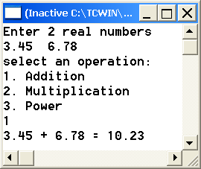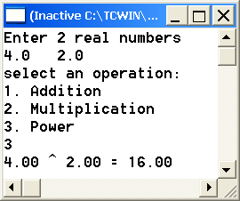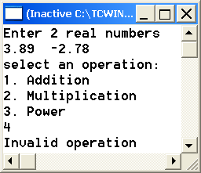
#include <stdio.h>
#include <math.h>
int main() {
double n1,n2,result;
int choice;
printf ("Enter 2 real numbers \n");
scanf("%lf%lf",&n1,&n2);
printf("select an operation:\n");
printf("1. Addition\n”);
printf(“2. Multiplication\n”);
printf(“3. Power\n");
scanf("%d",&choice);
if(choice==1) {
result=n1+n2;
printf("%.2f + %.2f = %.2f\n",n1,n2,result);
}
else if (choice == 2) {
result=n1*n2;
printf("%.2f x %.2f = %.2f\n",n1,n2,result);
}
else if (choice == 3 ) {
result=pow(n1,n2);
printf("%.2f ^ %.2f = %.2f\n",n1,n2,result);
}
else
printf ("Invalid operation");
return 0;
}

Other solution using switch
#include <stdio.h>
#include <math.h>
int main() {
double n1,n2,result;
int choice;
printf ("Enter 2 real numbers \n");
scanf("%lf%lf",&n1,&n2);
printf("select an operation:\n");
printf("1. Addition\n”);
printf(“2. Multiplication\n”);
printf(“3. Power\n");
scanf("%d",&choice);
switch (choice) {
case 1: result=n1+n2;
printf("%.2f + %.2f = %.2f\n",n1,n2,result);
break;
case 2: result=n1*n2;
printf("%.2f x %.2f = %.2f\n",n1,n2,result);
break;
case 3: result=pow(n1,n2);
printf("%.2f ^ %.2f = %.2f\n",n1,n2,result);
break;
default: printf ("Invalid operation");
}
return 0;
}

